The switch statement contains multiple blocks of code called cases and a single case is executed based on the variable which is being switched.

Syntax:

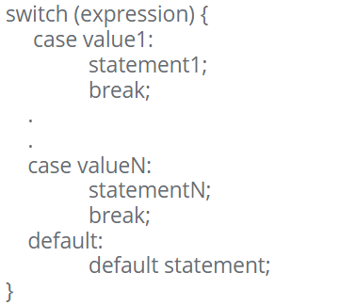

Example:

